What can I Submit to the PAS Meeting?
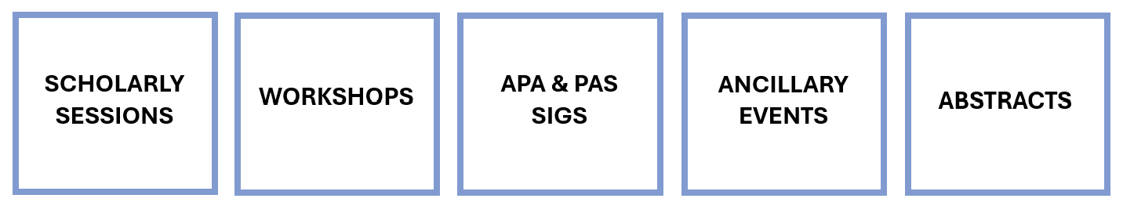

Scholarly Sessions
Top academic pediatricians, policymakers, and clinicians utilize a variety of innovative approaches to address high-quality, scholarly topics of interest to the broad constituencies attending the PAS Meeting.

Scholarly Session Types:

Basic Clinical Translational Roundtables
Encourage collaboration between basic scientists, translational researchers, and clinicians. Roundtables outline a pediatric healthcare challenge and investigative approach, provide an overview of new therapeutic applications, and discuss emerging mechanisms and biological effects being discovered. The goal: to identify areas for further exploration, develop novel research, and optimize therapies.

Debate/Pro-Con Discussions
Address a variety of controversies across pediatrics: diagnostics, medical management, therapeutics, research strategies, policy, and more. Look for robust debate and audience participation across 2-3 related topics.

Panel Discussions
Provide an interesting and engaging learning opportunity. Led by a moderator with subject area expertise, 3-5 panelists dive deep into timely pediatric issues.

Hot Topic Symposia
Focus on issues targeted to more specialized audiences, e.g., subspecialists, general pediatricians, educators, etc., than those covered in State-of-the-Art Plenary sessions. Hot Topic Symposia generally include 3-4 presentations with time for active audience discussion.

State of the Art Plenary Sessions
Present seminal advances in pediatrics featuring issues with a major impact on the health of children—advances in biomedical research, health policy, and other issues affecting the academic pediatrics field. Plenary sessions usually have invited lectures from one to three recognized leaders.

Clubs
- Focused sessions that are organized by PAS and club members and are open to all attendees at no additional fee.
  - Audrey K. Brown Kernicterus Symposium • Bilirubin Club • Bioethics Interest Group • Directors of Research Club • Lung Club • Milk Club • Neonatal Feeding Club • Neonatal Hemodynamics Club • Neonatal Sepsis Club • NICU Follow Up Club • Pediatric Hospital Medicine Club • Perinatal Brain Club • Perinatal Nutrition Club

Workshops

Workshop submissions are extremely competitive every year; on average, only about 25% of submissions are accepted.
While the format may vary, workshops should be designed to facilitate discussions between workshop leaders and participants. The workshop may include a short didactic presentation, but the overall intention of these sessions is to actively involve the attendees in the learning process. Workshop leaders and participants should be prepared to dive into this cooperative venture jointly! To maximize the diversity of topics and leaders, preference may be given to workshops that have not been presented in both of the past two years. We also encourage the development of workshops that appeal to more senior faculty as well as trainees. Workshops will be selected to maximize audience participation and ensure a broad diversity of topics.

APA and PAS SIGs

APA SIGS
Informal sessions sponsored by the Academic Pediatric Association (APA), SIGs are organized around specific academic and community pediatrician interest areas.

PAS SIGS
Informal sessions sponsored by the Pediatric Academic Societies (PAS), SIGs are organized around specific academic and community pediatrician interest areas.

Ancillary Events
Ancillary Events are held in conjunction with the PAS Meeting, are coordinated by groups other than PAS, and do not include educational content. Functions held adjunct to the PAS Meeting and coordinated by a group other than PAS are considered an ancillary event. Educational and scientific programming, organized outside of PAS yet directed at the same audience, may not be offered over the official dates of the PAS Annual Meeting within 100 miles of the PAS meeting location. Ancillary Events should advance the vision of the PAS Meeting, the field of academic pediatrics, and pediatric research and should not detract from or compete with official PAS programming or events.

Event types include:
- Alumni Event
- Business Meeting
- Committee Meetings
- Dinner
- Luncheon
- Reception
- ISS—Industry Sponsored Symposia
- SCS—Sponsored Commercial Symposia

Abstracts
Presentation formats (platform, poster, or poster symposium) are determined in January by the PAS Program Committee.
  - Platform sessions are 90 minutes long. Presentations are 15 minutes (10 minute/presentation; 5 minute/discussion).
  - Poster symposium sessions are 90 minutes in length and consist of a poster viewing period followed by a formal presentation or discussion period. Session moderators determine the presentation or discussion format for poster symposium sessions.
  - Poster sessions are two-three hours in length and consist of a general viewing and author attendance period.

